

**Ohio Department of Transportation**

Division of Information Technology

1. **How to Prepare Your Online Account Prior to Installation**
2. **Installing the Collector Application**
3. **Using the Collector Application**

**<InspectTech Laptop Collector>**

**Installation and User Manual 1.2**

September 3, 2014

Ohio Department of Transportation

1980 W. BROAD ST., COLUMBUS, OHIO, USA 43223

Copyright © 2014, All rights reserved

# How to prepare your online account prior to install

Ensure your laptop meets the minimum requirements prior to install. For example one issue we discovered in testing the install is that the app will not install on a 32-bit laptop.

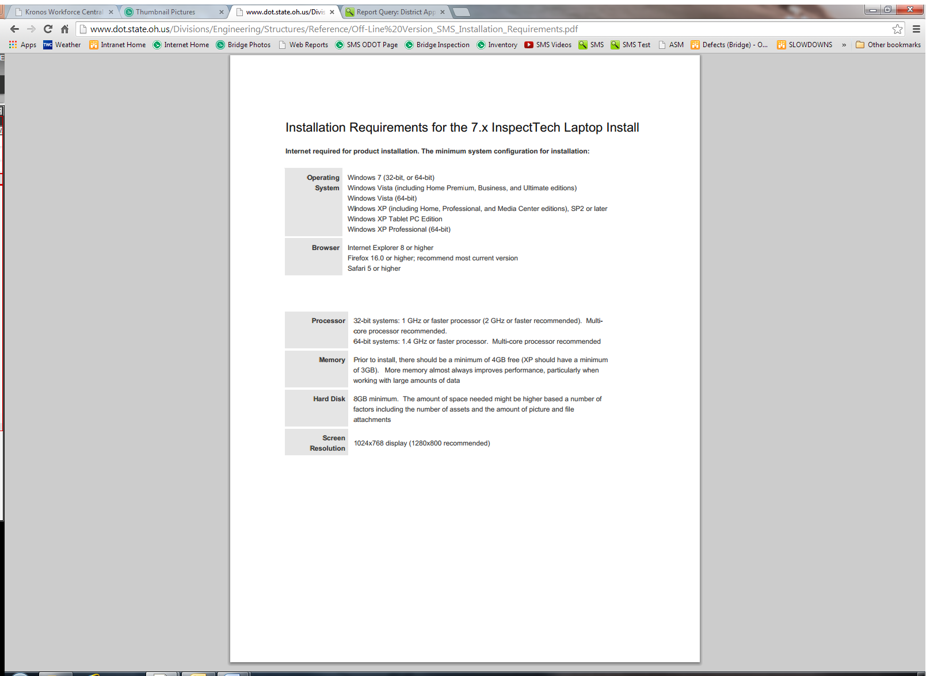

Prior to install the initial setup will run faster if inspectors limit reduce their working set:

1. Login to *SMS.transportation.ohio.gov* online
2. Go to Main>My Account
3. The next step is creating an offline password or keep one of the defaults:
   1. Odot20!3 or
   2. Odot20!4.
4. To Create your own password, Go to the SMS online site and go to My Account under the MAIN dropdown menu, and enter, and confirm, a new password for your offline use . **(Even if you have changed your offline password in the past, you must create a new one for the new installation)**. Use the Save button at the upper right before leaving the MY ACCOUNT screen. There will be certain rules for the new password, such as 8 characters, upper case, lower case, number, etc.

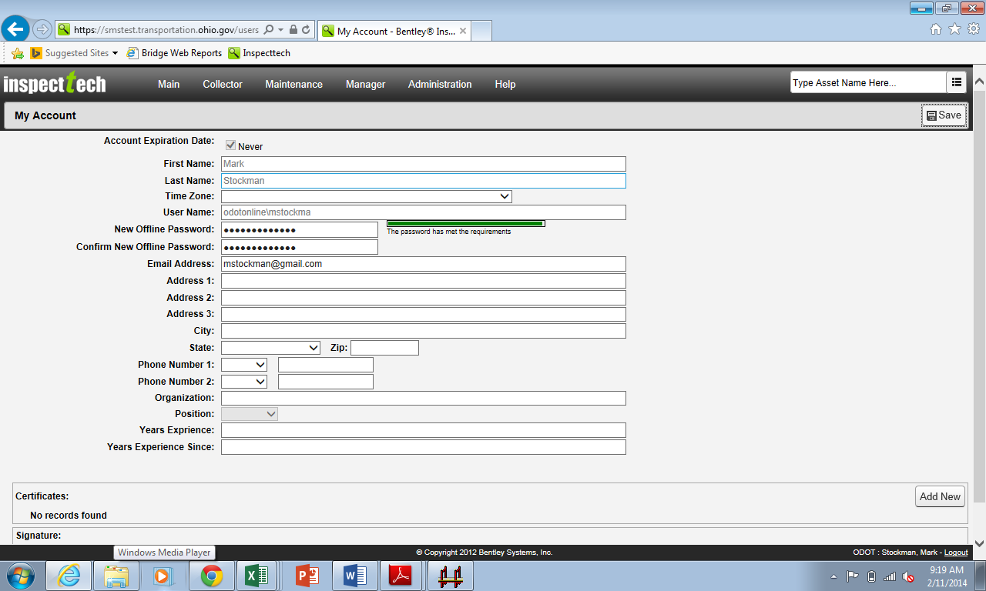

1. Go to Main>My Working Set
2. Check that your working set is set to 300 or less, even if you have set it in the past. For the initial install Unselect All Assets (keeping your working set very small will speed up the initial sync process and it won’t install with more than 300).

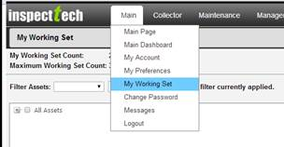

7, After unclicking the box for All Assets, double click on the words All Assets, or, click the box with the “+” sign in it, and the asset tree will open and expand. You can then navigate to choose the bridges that you want in your working set. (for example, open and expand All Assets, Bridges, County Agency. etc.). You continue double clicking the words in the asset tree (or the “+” sign) until you get to the specific bridges you want to work on, and select the box next to those bridges.

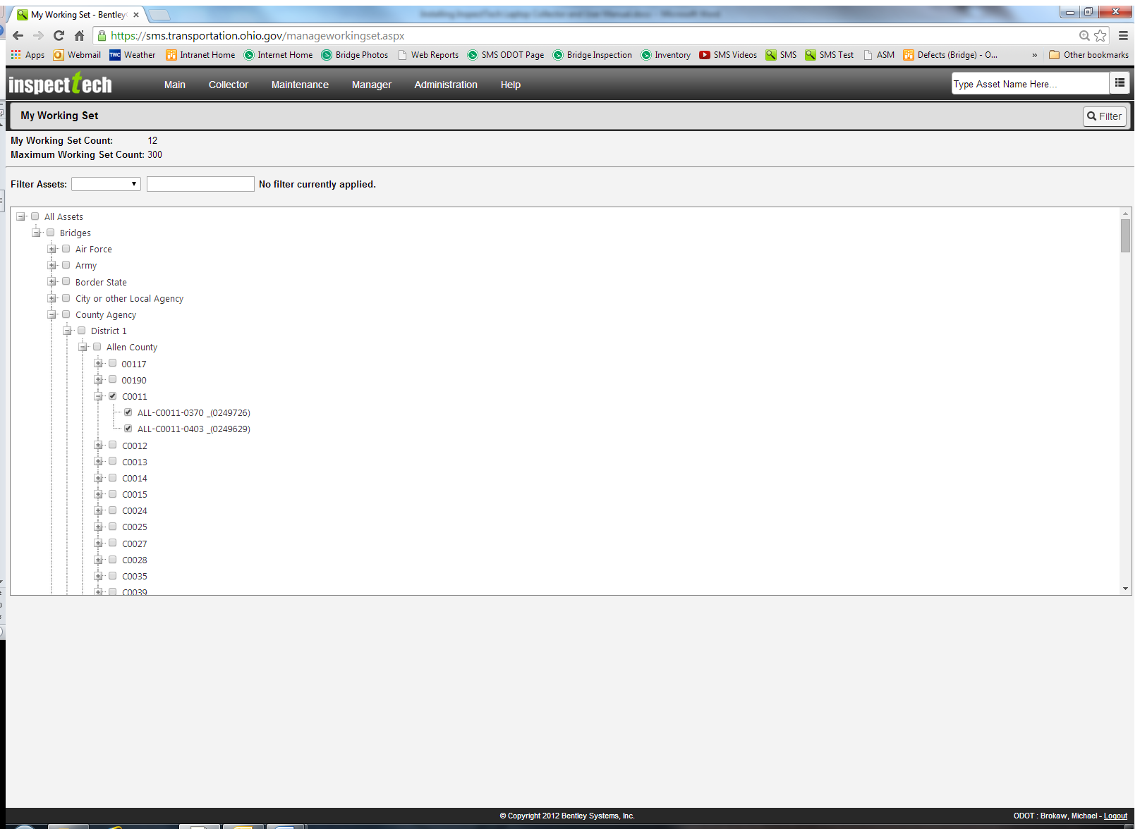

# How to Install the Laptop App

You must be connected to the Internet in order to install the laptop application. For best results, please use a hard-wired connection.

1. Find the ODOT Laptop Collector – Prod.zip file. It is located on the FTP site:

<ftp://ftp.dot.state.oh.us/pub/Structures/BMS/Web_download_files/SMS%20Collector%20Application/>

1. **Download**, copy or save the ODOT Laptop Collector – Prod.zip file to your **desktop**.
2. Unzip the ODOT Laptop Collector – PROD folder by choosing the Extract Files in the menu bar and save to your **Desktop**.
3. Open the unzipped folder.

Navigate to **ODOT > ODOT Laptop Collector – Prod > en-us**. **If you are running Windows 8 or 8.1 proceed as below. Otherwise proceed to step 5.**

**Open the DotNetFX35SP1 folder. Right click dotNetFx35setup and run as an administrator.**

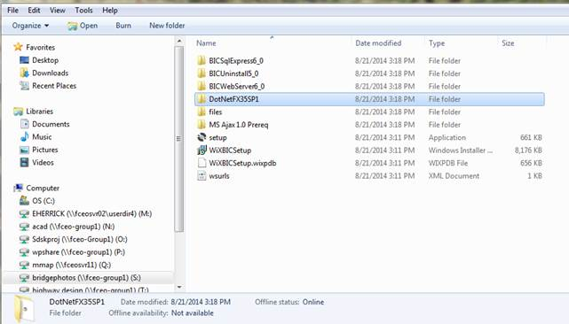

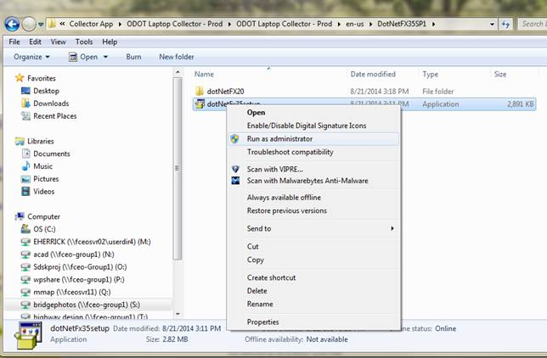

1. **Go back to the ‘en-us’ folder and Right Click** the setup file and **Run as Administrator if you are installing for someone else. If you are using this application and able to install on your own computer then double click ‘setup’**. A new dialog will generate.

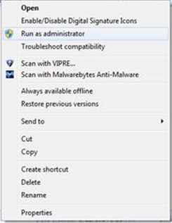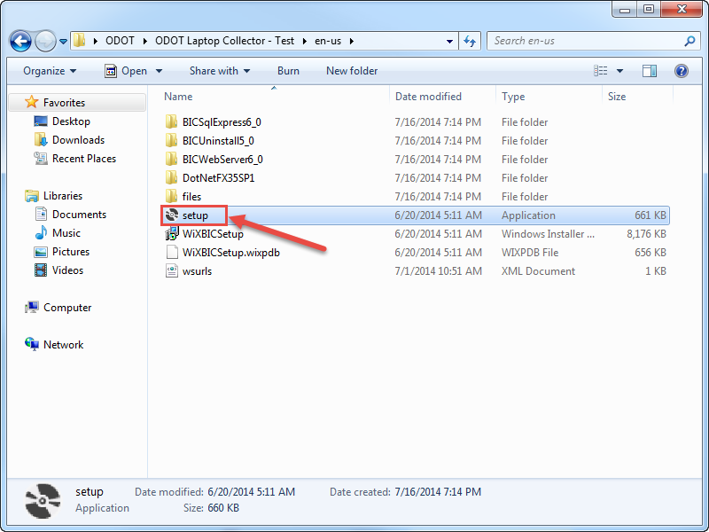

1. Click **Install**

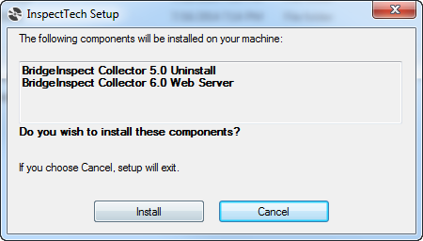

1. Click **Next**

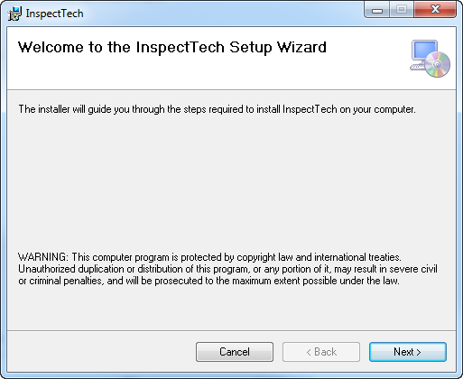

1. Peruse the End User License Agreement

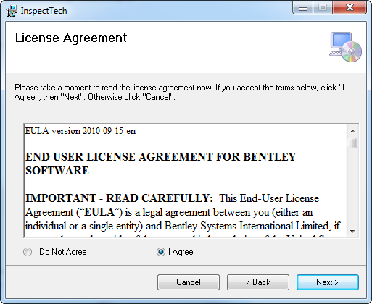

1. Select **I Agree** to confirm
2. Click **Next**
3. Enter a Client ID, User Name, and Password.
   * Enter **ODOT** into all three fields.
   * This is a case sensitive field.

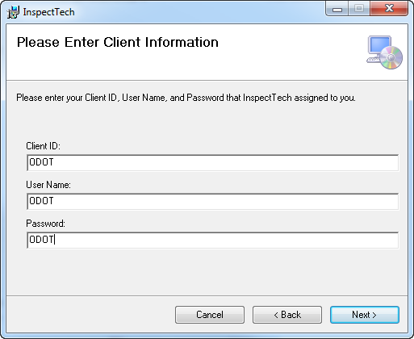

1. Click **Next**

Note: The credentials for these fields are identical for every user within ODOT.

1. Click **Next**.

Note: If you are installing i.e. you are the admin of your computer select “Just Me”. If you are installing for someone else then select “Everyone”. Only one SMS user can use the installed offline version on one laptop. Do not change the install path. If changed, some features may be unavailable.

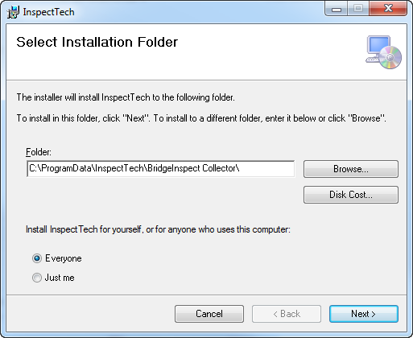

1. Click **Next**

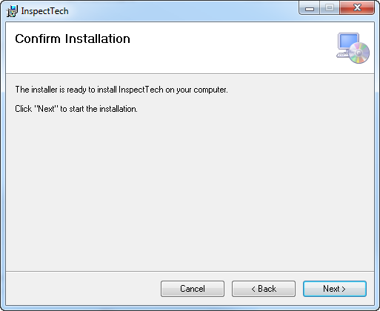

Wait

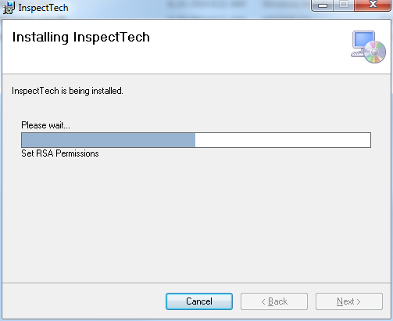

1. Click **Close**

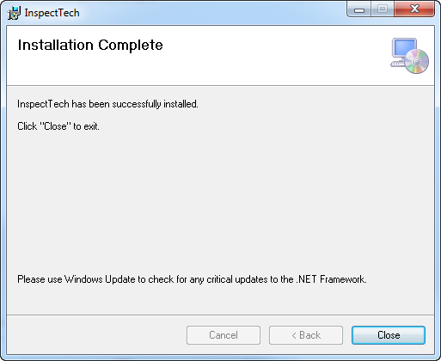

* + Find The InspectTech Collector icon will appear on your desktop.

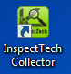

1. Double left click the InspectTech Collector icon to open InspecTech Collector. Wait.

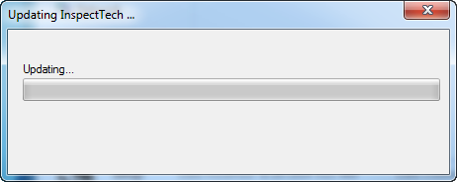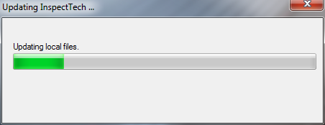

* + The application will perform a series of updates in order to synch the app with the most recent online files. Continue waiting.

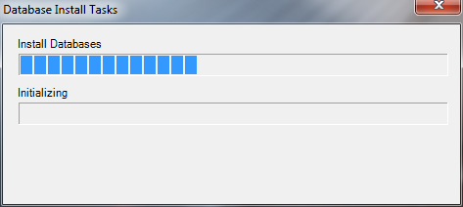

1. If you get an error at any time during the install select “copy text” and paste it into an email to [SMS@dot.state.oh.us](mailto:SMS@dot.state.oh.us). This will be passed onto developers.

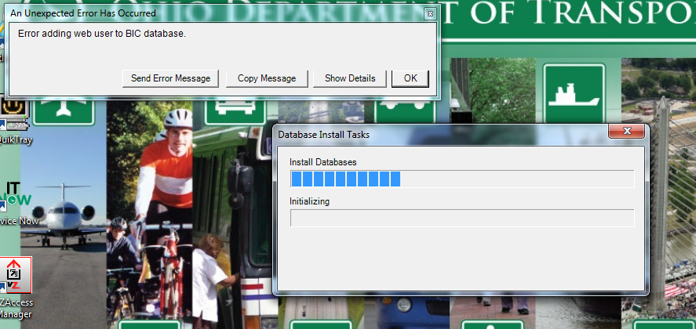

1. Log into InspectTech using your **regular username and newly created offline password**. See page 3 of this document step 4. First use your offline password by selecting the “Use offline credentials” box. Your username will begin with the prefix: dot\ for ODOT employees or odotonline\ for non-ODOT employees.

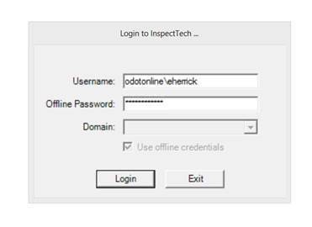

* + The application will build the local database and update it with the most recent data. These updates are extensive and might take an extended amount of time.

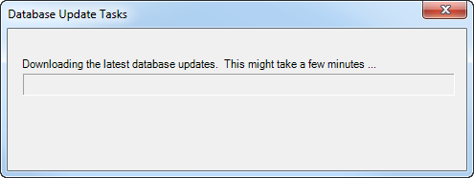

* + Once these updates are complete, the laptop application is ready to use. Select “**Done**”

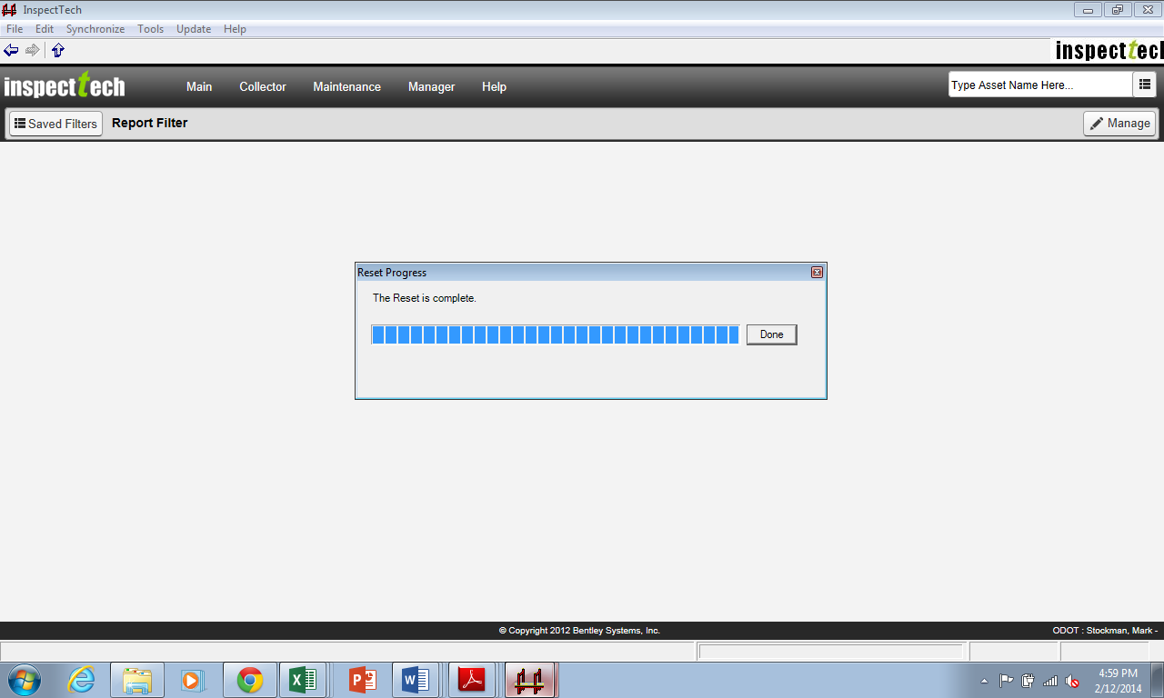

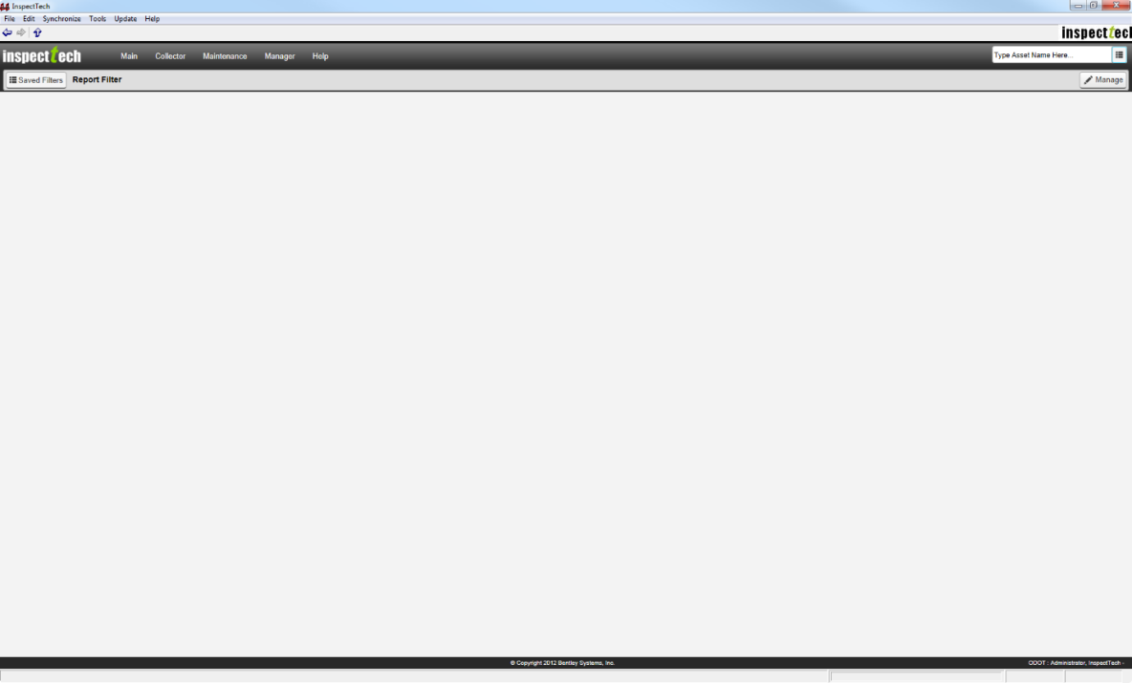

**3. Using the Collector**

You control your **Working Set** and **Offline Password** from the online version or *sms.transportation.ohio.gov.* The Laptop OFFLINE version is meant to only be used during the inspection to collect data. All printing, queries, and running reports is to be done with the ONLINE version. That is why it has fewer menu options.\

1. Go into the online version to add bridges to your **Working Set**. These are bridges that you will ‘check out’ in order to inspect and update offline.
2. Add bridges to your working set from the Online version.  Select bridges individually, per Route in the county or per county. Make sure not to exceed 300 bridges in your working set.

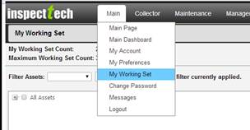

1. Open up the ‘branches’ in My Working Set until you get to where you want to go (County Level or Route Level or down to the individual bridge) and check the bridges you want to check out.  In the example below Marysville and all of the routes and bridges under Marysville was added to my working set.

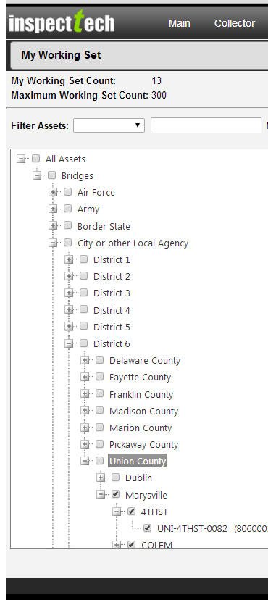

1. Open the Collector Icon on your Desktop while still online, it looks like this:

cid:image006.jpg@01CFB64E.B4862BF0

1. **Log into InspectTech using your** **regular username and newly created offline password.** Your password is managed by you in the Online version within Main>My Preferences. Only one inspector can use the collector on a laptop i.e. more than one inspector can not log into the collector per laptop.

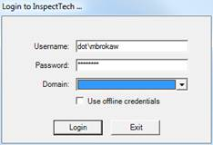

NOTE: When logging into the Offline App when you are not online, the box for “Use Offline credentials” will already be checked automatically and greyed out. You will have to use your offline credentials i.e. the password that you created in the Online version (or one of the defaults Odot20!3 or Odot20!4).

1. Select Synchronize>Synchronize Reports in My Working Set in order to get the most up-to-the-date bridge information

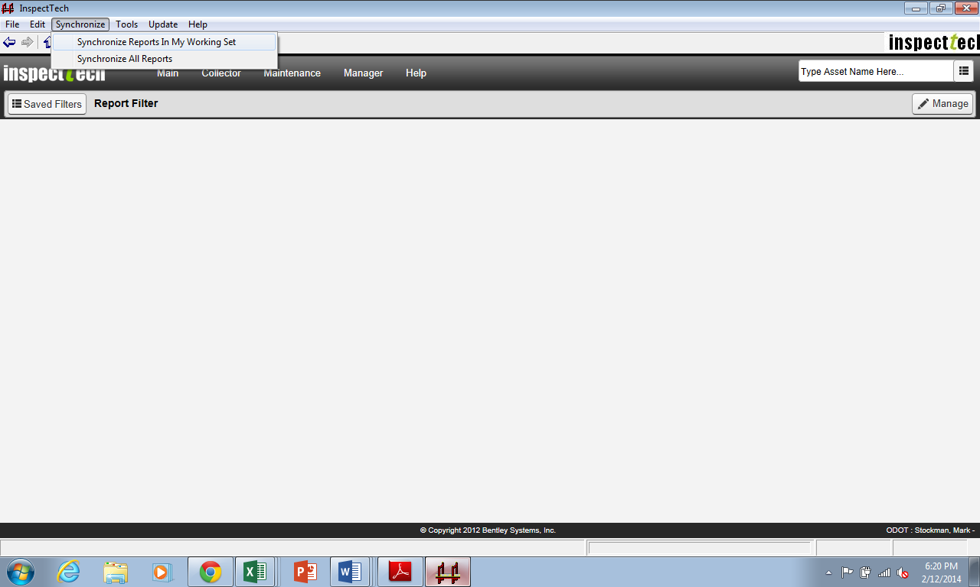

1. The working set you established will be identified by the “**(WS)**” in the offline app to the right of the text in the tree. The Working Set is intended to be a small group of bridges that will be inspected over a short time frame (several days or week). After that small group of bridges is inspected, it is intended that you upload the inspection data to the SMS server and create a new Working Set for your next batch of bridges to inspect. The Laptop App loads all of your bridge names as ‘shells’ but they are not all populated with data. You can see the Bridge Asset name on all bridges but only bridges in your Working Set will have data (after you do a working set synchronization).

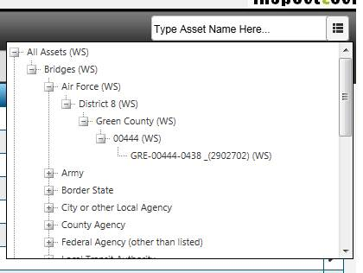

1. Find bridge detail pages of bridges in your working set and Create reports.
2. NOTE: Photos are not currently being brought from the collector into the online version. In the meantime do not attach photos and files to the offline collector app.
3. The dropdown menus for the Collector have fewer options than the online version. The purpose of the collector is to collect data:

**Main** – Main Page

My Preferences

**Collector** - Inspection Schedule

Pending Uploads

Report Status Counts

Child Assets

**Maintenance** - Manage Maintenance by Asset

**Manager** - Archived Assets

**Help** - About

Help with Multiple Photo Upload

1. Instead of Submit Report for Review you have the option to **Upload Report**.
2. The next time you are connected to the internet (recommend hard wired) open up the collector app (keep the online version closed), go to Collector>Pending Uploads and select bridges to upload and then upload.  You have essentially brought in your In Progress Reports into the online version.
3. You still have to submit these for review. There isn’t a batch submit button yet but if you go to Collector>Report Filter>Saved Filters>My In Progress Reports you can see all of your in-progress reports.  From here you can select the wrench and submit for review one at a time.
4. Should you need to adjust your screen resolution:

Right click any open space on the desktop

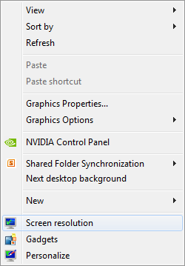

Select **Screen Resolution**

